**Part 4 - Routing**

**Part 4.1 Basic Routing**

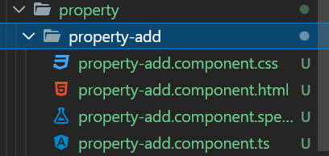

First one, please create property-add component

**Open app.module.ts**



Import above component



Import these modules

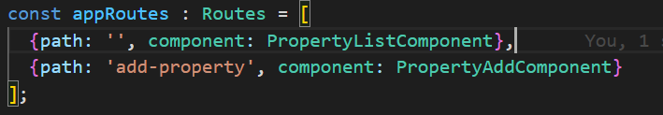

Define the route path

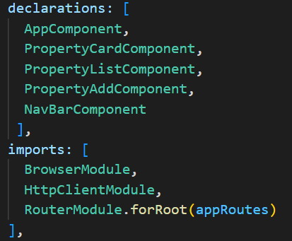

Register component and route path

Open app.component.html

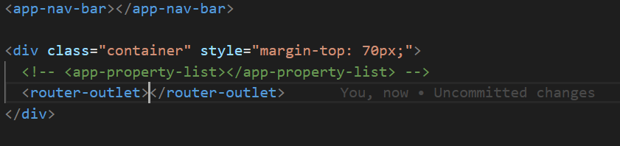

Router outlet like a replacement template. Once we click the route in URL address , then content of component will be displayed within router outlet

Open nav-bar.component.html

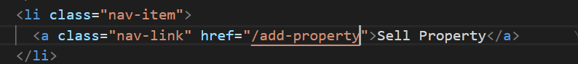

This href value likes route path that we have defined in app.module

<https://www.youtube.com/watch?v=rufosiklp-0&list=PL_NVFNExoAxclqXo9fLAeP0G2Qp56Fu8C&index=12>

**Part 4.2 Routing advanced**

Here we will learn about

1. Replacing href attribute to routerLink
2. routerLinkActive and routerLinkActiveOptions
3. Routing with parameter path (http://localhost:4200/detail-property/1)
4. Routing redirection

The problem will be faced when using href attribute instead of routerLink is the application will reload the pages

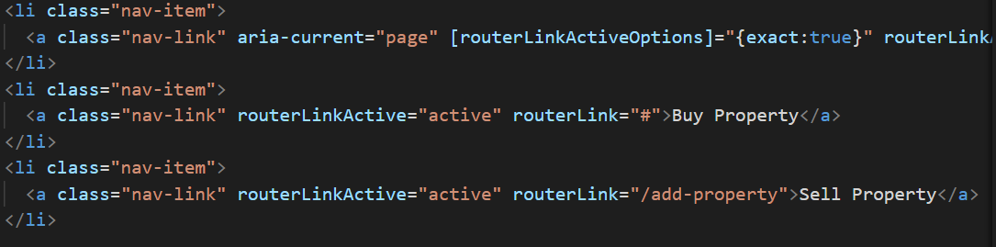

**routerLinkActive**

Track weather link route is active or not. If the link is active then css class will be applied. “active” is css class, therefore you able to change with any class you want.

**routerLinkActiveOptions {exact:true}**

It will ensure that the link is active exactly

It will be useful when we have a component and loaded into several route. For example “dashboard component”. The first route is “/” and the other “/dashboard”. If user click “/dashboard” then the link that use “/” route will be considered as active as well. So to prevent the case, we use the attribute

**Routing with parameter**

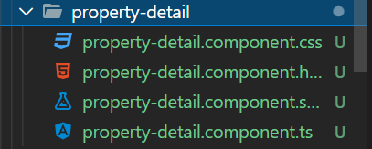

Create component property-detail



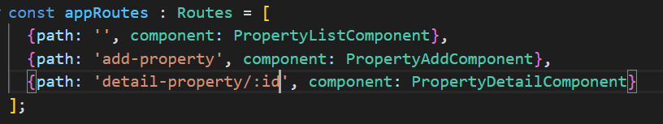

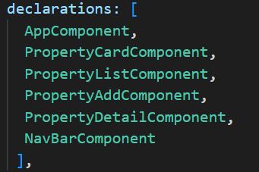

Modify app.module.ts

Open property-card.component.html



Open property-detail.component.ts

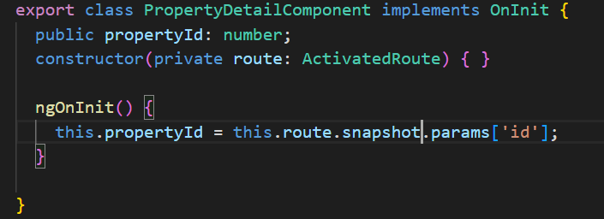

Open property-detail.component.html

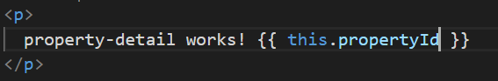

**Redirect to other route / component**

Open property-add.component.ts

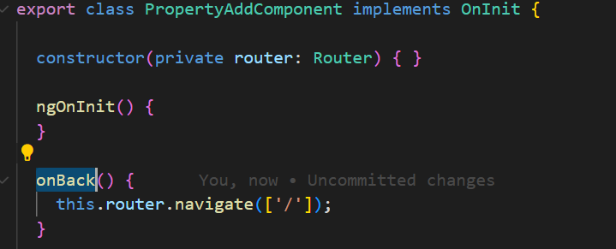

Open property-add.component.html

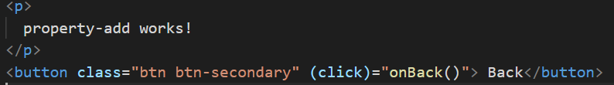

Here we use event binding “(click)”

<https://www.youtube.com/watch?v=i1Zjz4QYhx8&list=PL_NVFNExoAxclqXo9fLAeP0G2Qp56Fu8C&index=13>